Fine Tuning: -
Giving the Path where the training data is stored in both input and output file

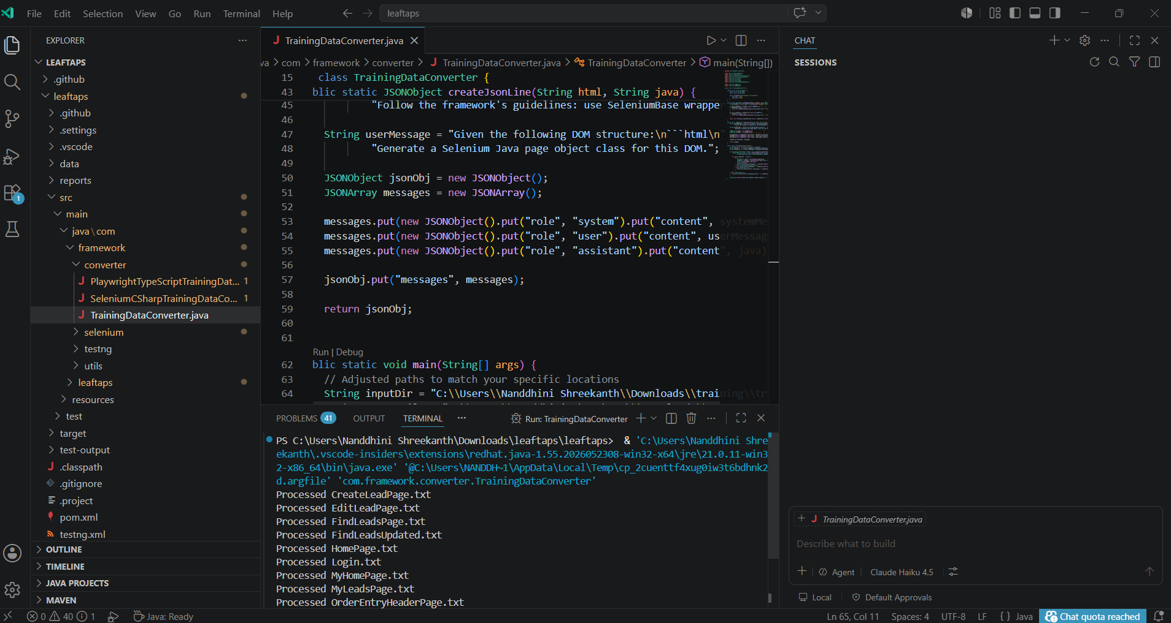

Verifying the Jsonl file is created in the output file path
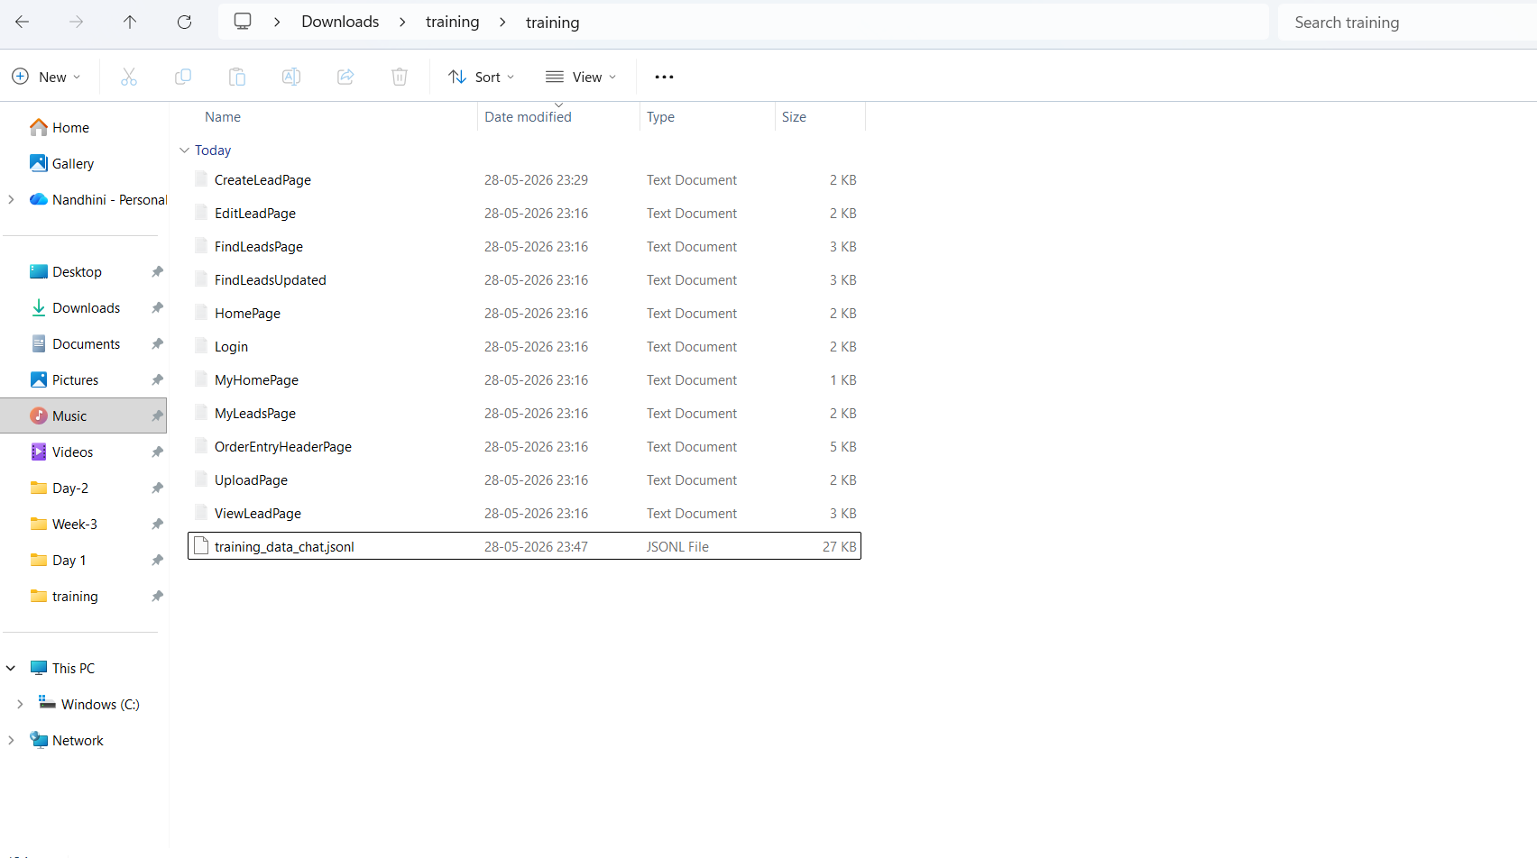

Verifying the jsonl file output which is created
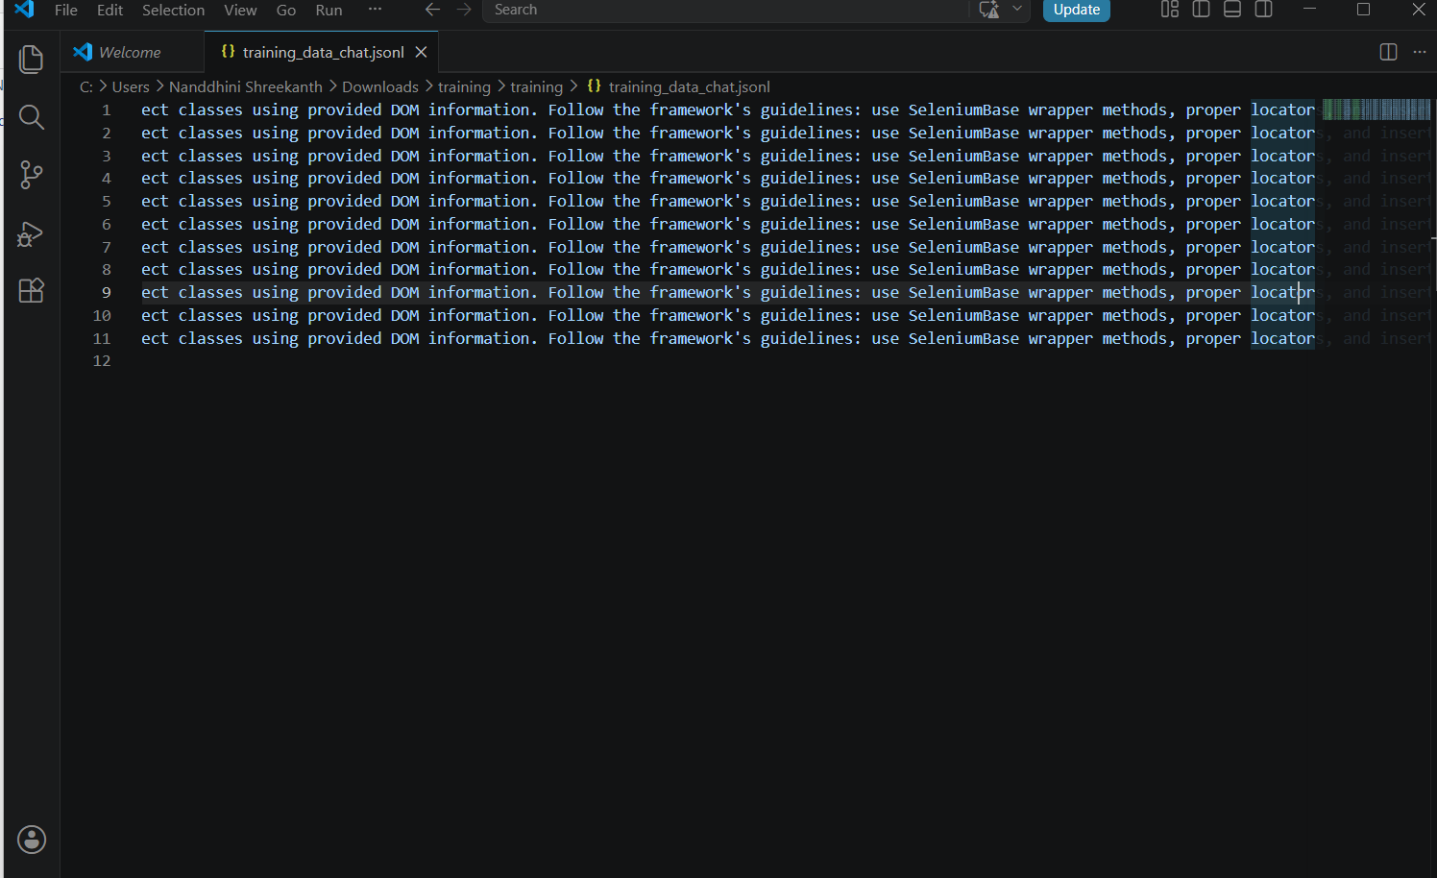

Upload the jsonl file in storage in https://api.testleaf.com/storage
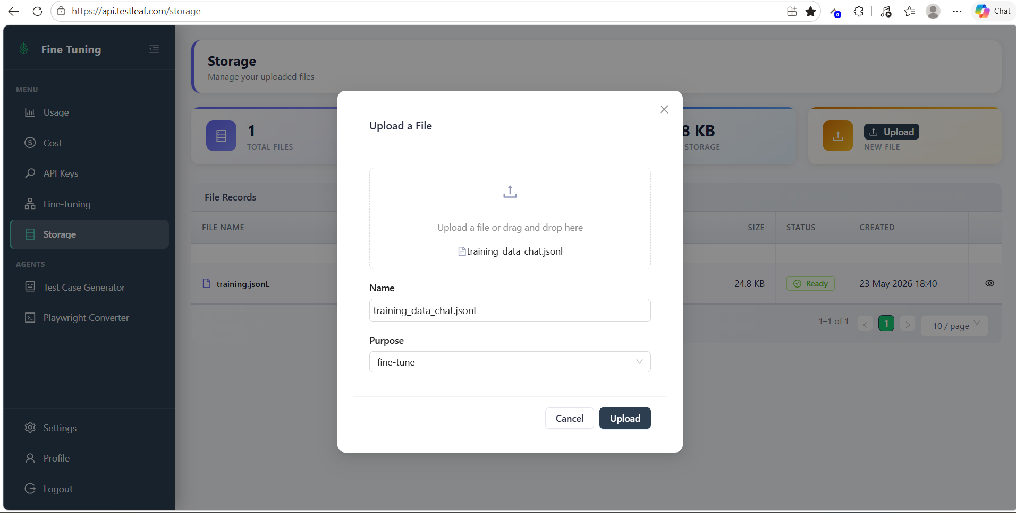
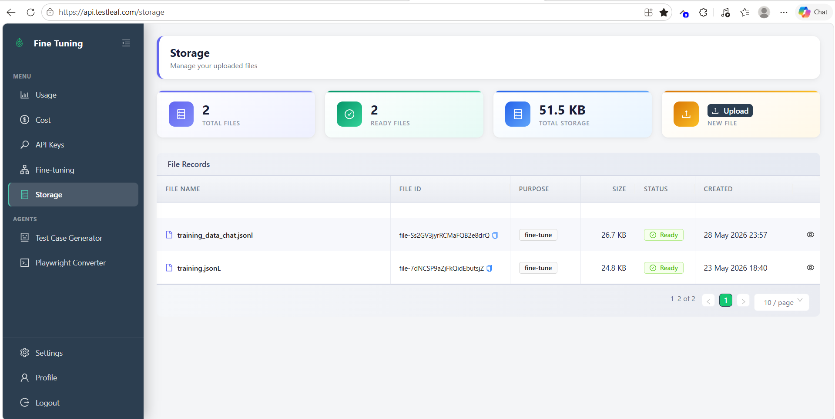

Creating a fine tune modal with Batch size as 1, learning Rate Multiplier as 0.60 and Number of Epochs as 4
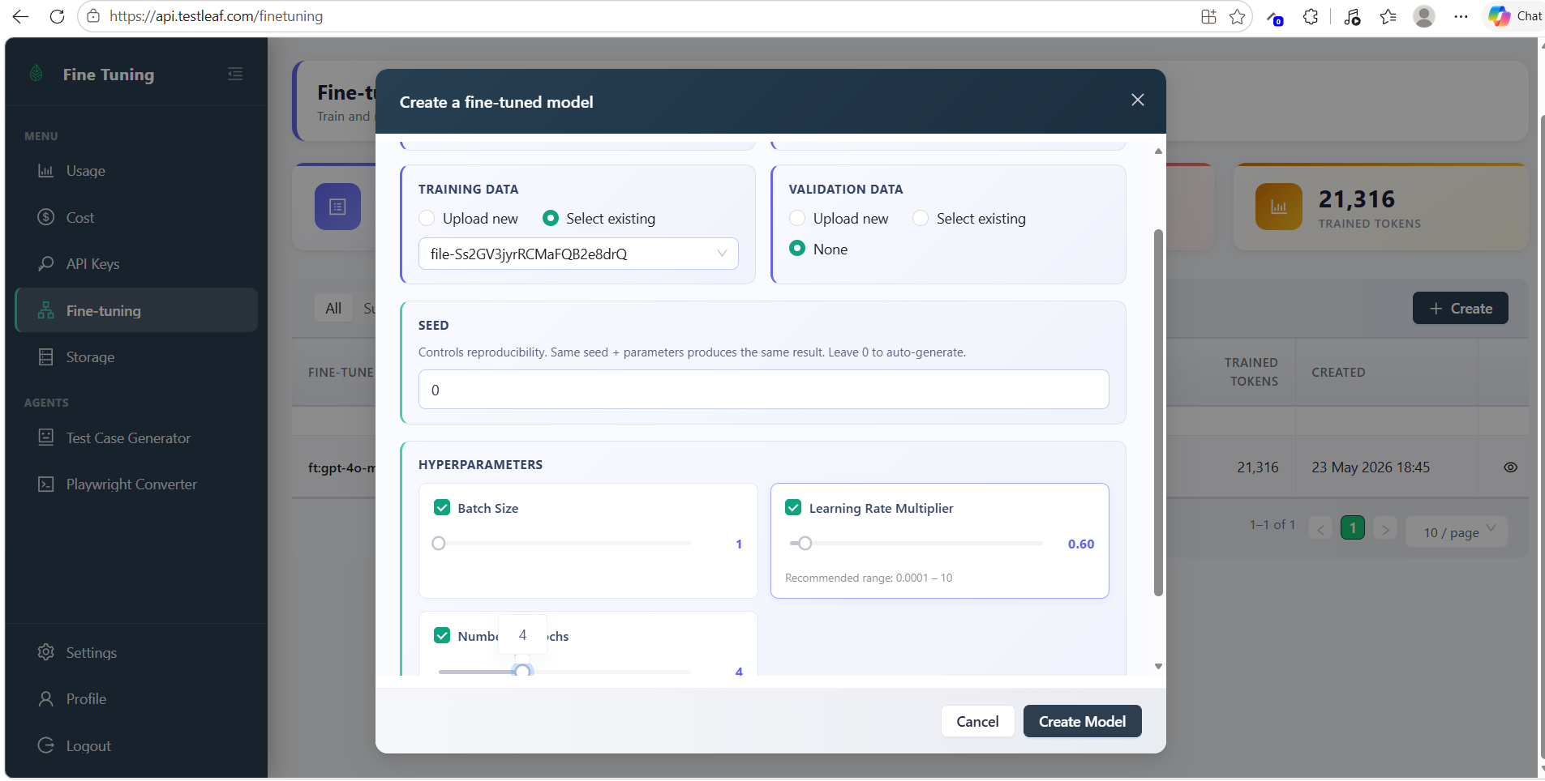

Fine Tune modal is succeeded

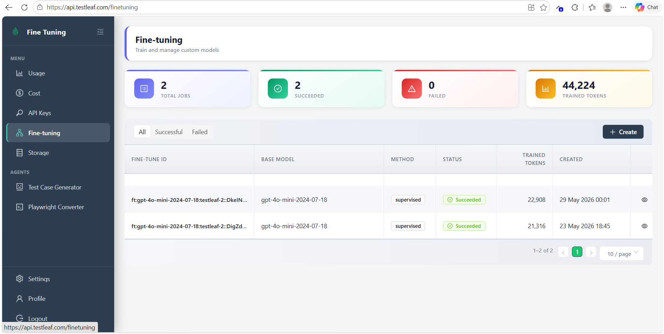

Go to AI extension folder and go to popup.js and replace the file given
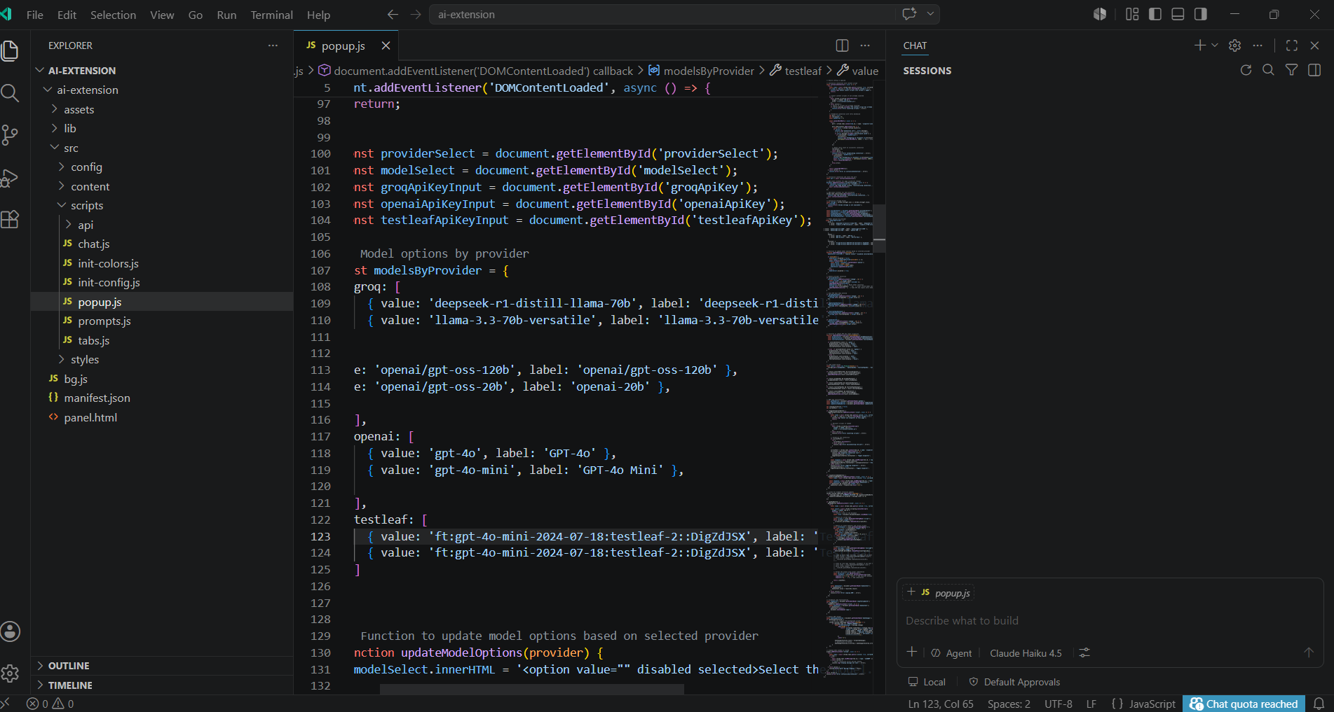
Giving the API key in TestLeaf API key and inspect the company name, First name, Last name, Create Lead button and click generate
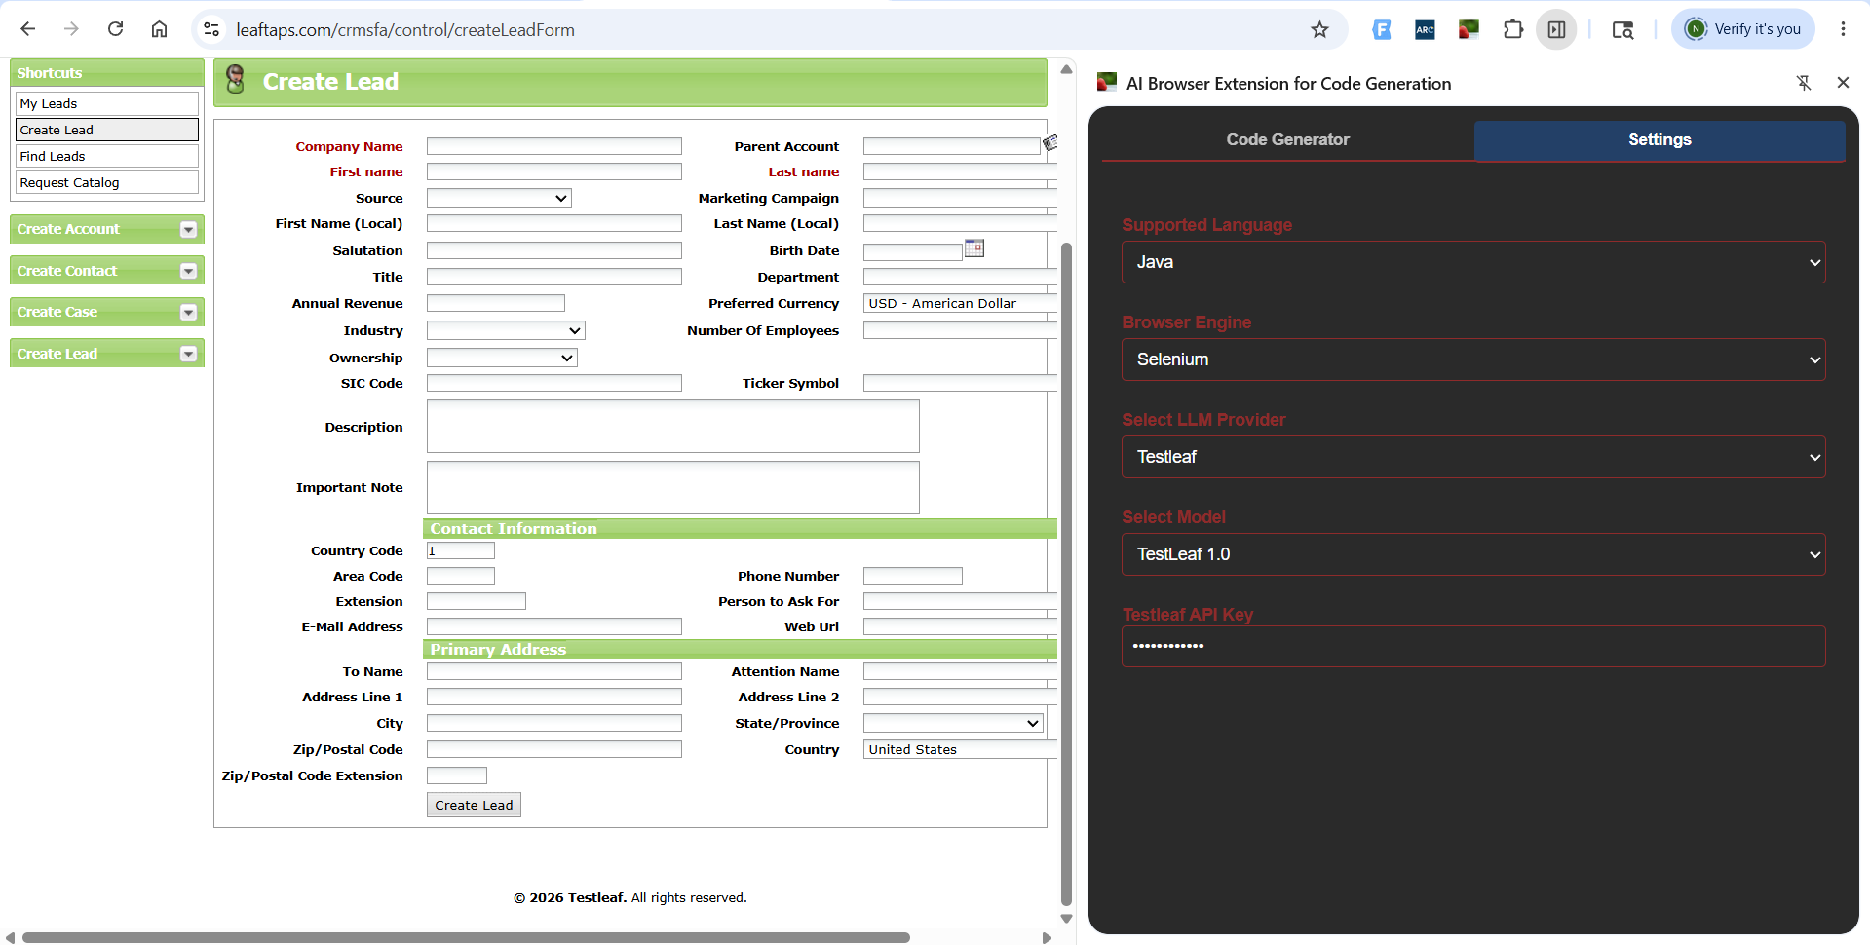

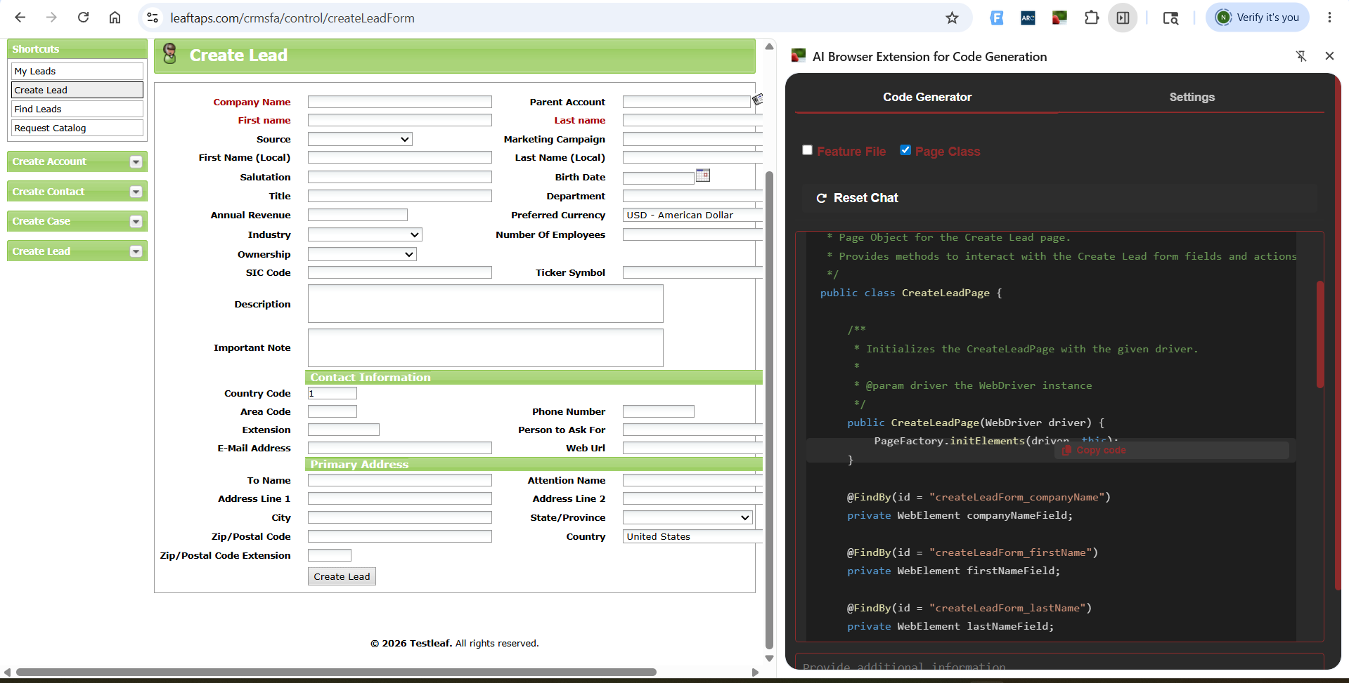
Output File
package com.testleaf.pages;

import org.openqa.selenium.WebElement;
import org.openqa.selenium.support.FindBy;
import org.openqa.selenium.support.PageFactory;

/**
* Page Object for the Create Lead page.
* Provides methods to interact with the Create Lead form fields and actions.
*/
public class CreateLeadPage {

/**
* Initializes the CreateLeadPage with the given driver.
*
* @param driver the WebDriver instance
*/
public CreateLeadPage(WebDriver driver) {
PageFactory.initElements(driver, this);
}

@FindBy(id = "createLeadForm_companyName")
private WebElement companyNameField;

@FindBy(id = "createLeadForm_firstName")
private WebElement firstNameField;

@FindBy(id = "createLeadForm_lastName")
private WebElement lastNameField;

@FindBy(className = "smallSubmit")
private WebElement createLeadButton;

/**
* Enters the company name in the Create Lead form.
*
* @param companyName the company name to enter
* @return the CreateLeadPage instance
*/
public CreateLeadPage enterCompanyName(String companyName) {
companyNameField.clear();
companyNameField.sendKeys(companyName);
return this;
}

/**
* Enters the first name in the Create Lead form.
*
* @param firstName the first name to enter
* @return the CreateLeadPage instance
*/
public CreateLeadPage enterFirstName(String firstName) {
firstNameField.clear();
firstNameField.sendKeys(firstName);
return this;
}

/**
* Enters the last name in the Create Lead form.
*
* @param lastName the last name to enter
* @return the CreateLeadPage instance
*/
public CreateLeadPage enterLastName(String lastName) {
lastNameField.clear();
lastNameField.sendKeys(lastName);
return this;
}

/**
* Clicks the Create Lead button to submit the form.
*
* @return the ViewLeadPage instance
*/
public ViewLeadPage clickCreateLeadButton() {
createLeadButton.click();
return new ViewLeadPage(driver);
}

}

Giving the API key in TestLeaf API key and inspect the Username and Password and click generate
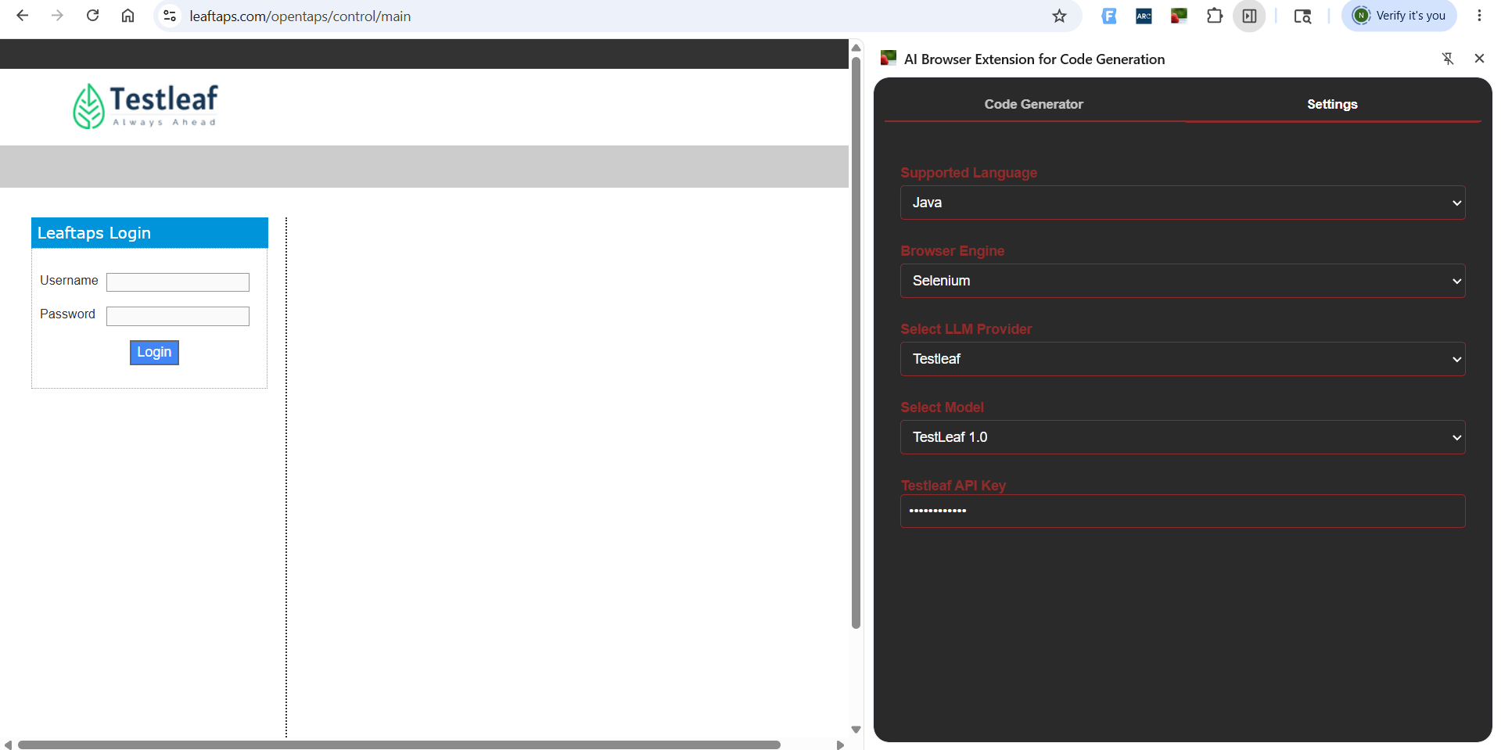

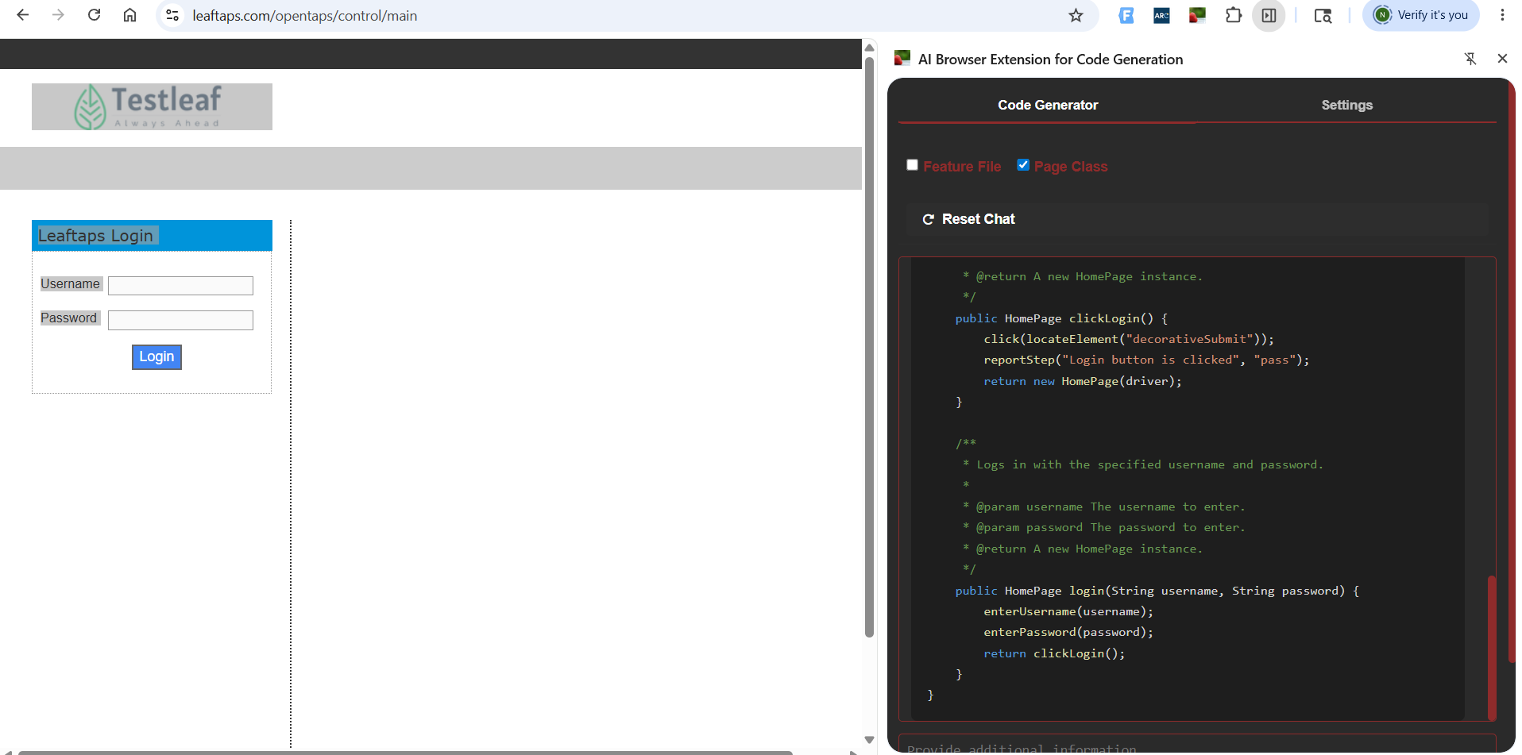

Output file
package com.testleaf.pages;

import org.openqa.selenium.By;
import org.openqa.selenium.remote.RemoteWebDriver;

/**
* Page Object for Login Page
*/
public class LoginPage extends AbstractPage {

/**
* Initializes a new instance of the LoginPage class.
*
* @param driver The WebDriver instance to use for this page.
*/
public LoginPage(RemoteWebDriver driver) {
super(driver);
}

/**
* Enters the username in the login form.
*
* @param username The username to enter.
* @return The current LoginPage instance.
*/
public LoginPage enterUsername(String username) {
clearAndType(locateElement("username"), username);
reportStep(username + " username is entered", "pass");
return this;
}

/**
* Enters the password in the login form.
*
* @param password The password to enter.
* @return The current LoginPage instance.
*/
public LoginPage enterPassword(String password) {
clearAndType(locateElement("password"), password);
reportStep(password + " password is entered", "pass");
return this;
}

/**
* Clicks the Login button to submit the form.
*
* @return A new HomePage instance.
*/
public HomePage clickLogin() {
click(locateElement("decorativeSubmit"));
reportStep("Login button is clicked", "pass");
return new HomePage(driver);
}

/**
* Logs in with the specified username and password.
*
* @param username The username to enter.
* @param password The password to enter.
* @return A new HomePage instance.
*/
public HomePage login(String username, String password) {
enterUsername(username);
enterPassword(password);
return clickLogin();
}
}

